Joining Live Lectures via WebEx for Students
- In Captured Classroom Content (Lecture Videos and Notes), Click to Join Live to view the Live Video Stream.
Note: The WebEx session will appear in a new window.

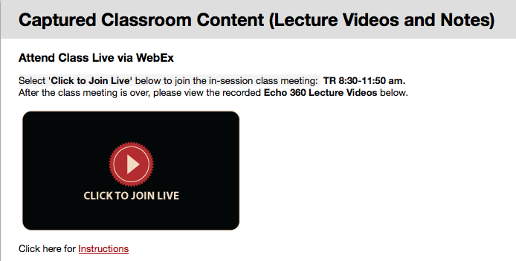

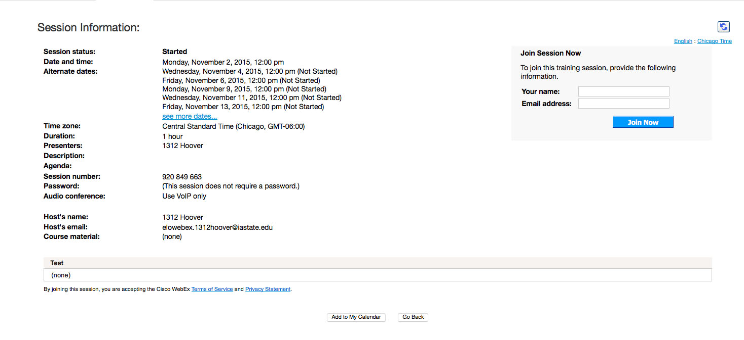

- In the Join Session Now box, enter your name. Your email address is optional.
Note: If this is your first time accessing WebEx, you may need to download the WebEx Add-on (.exe or .dmg file)

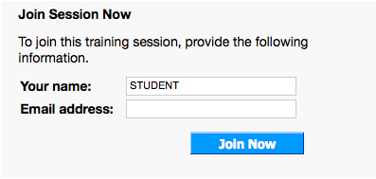

- Click Join Now. The live class meeting will appear on your screen.

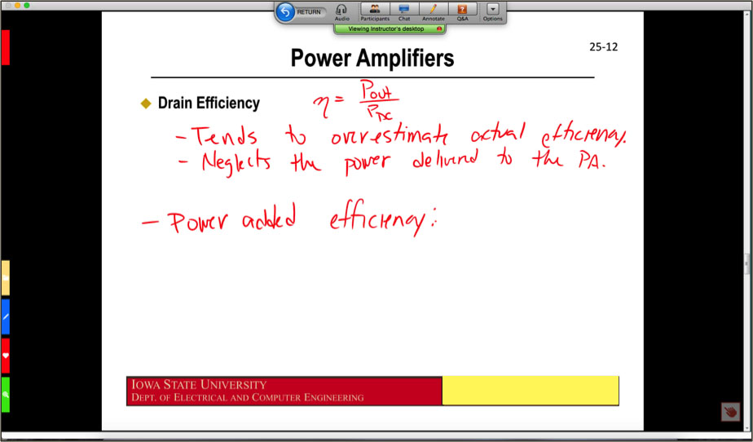

- Select Yes to hear audio for the class.

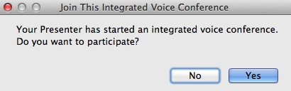

- You can set your speaker volume in the dialog box below.

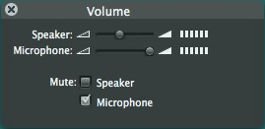

- Click the bar at the top of the screen to expand the menu of options.

- In the option menu, you can access several additional options.

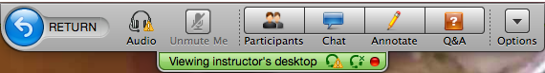

  - Select Participants to view the attendees.

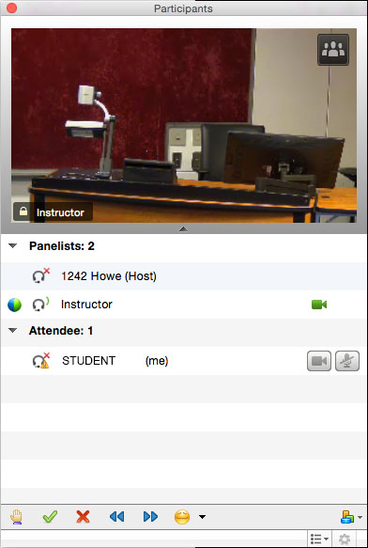

  - Select Chat to speak with participants. In Send to:, you may choose your message recipients.

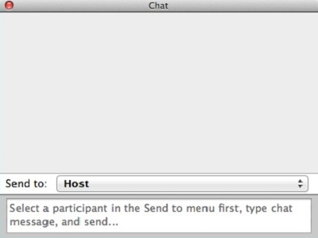

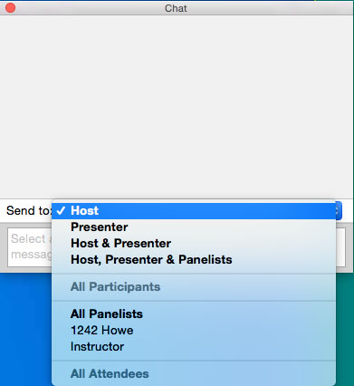

  - Select Audio to adjust volume.

- In the participant menu, attendees can select the hand icon to get the attention of the presenter.

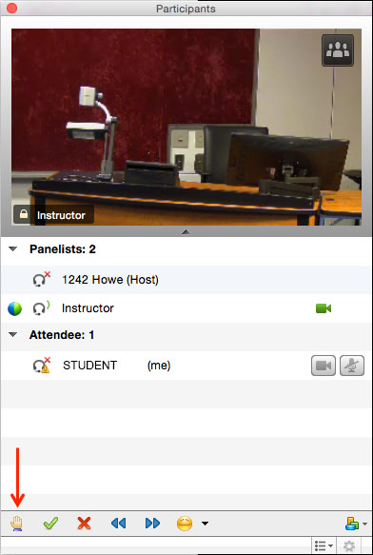

- If you are presenting in class, see the instructions for Presenting via WebEx for Students.

- Close the session at the end of class.

