Presenting via WebEx for Students
April 2016

A few points to keep in mind before you start:
- For best performance, you need to be on a wired connection.
- If you are presenting remotely, you will want to wear headphones/ear buds to control feedback.
- You will need a webcam and microphone (usually on most laptops).
- There may be a prompt for a short initial install (so you will need admin permissions).
- If your connection happens to drop, you can simply rejoin the session by clicking it again.

- In Captured Classroom Content (Lecture Videos and Notes), Click to Join Live to view the Live Video Stream.
Note: The WebEx session will appear in a new window.

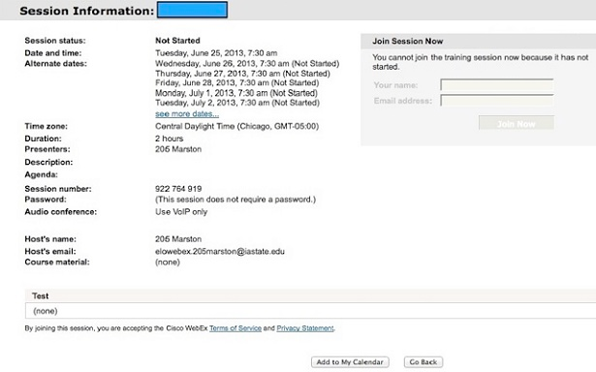

- Enter your name. Your email address is optional.

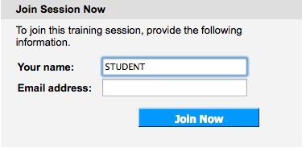

- Click Join Now. The live class meeting will appear on your screen.

*Note: If this is your first time accessing WebEx, you may need to download a WebEx Add-on. (Steps a. b. c.)

  - Click to download the file

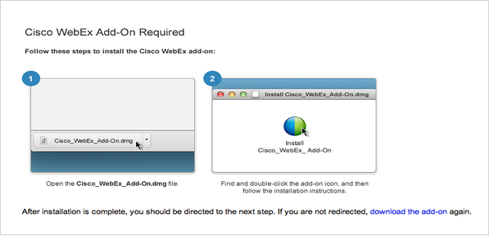

  - Open the downloaded file and click to run the file.

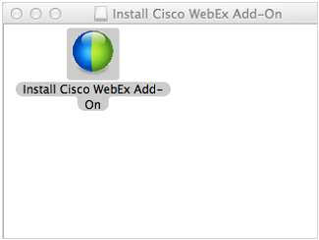

  - Allow WebEx to run in your browser as shown below.

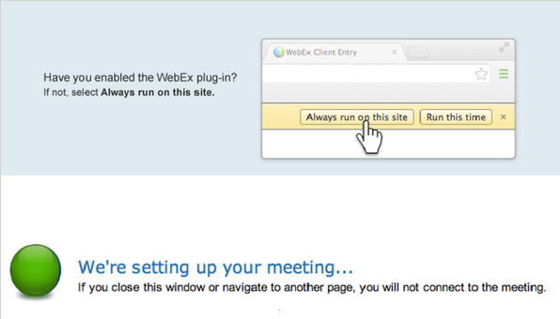

Next, join the live class meeting (Step 3). The class meeting will appear on your screen.

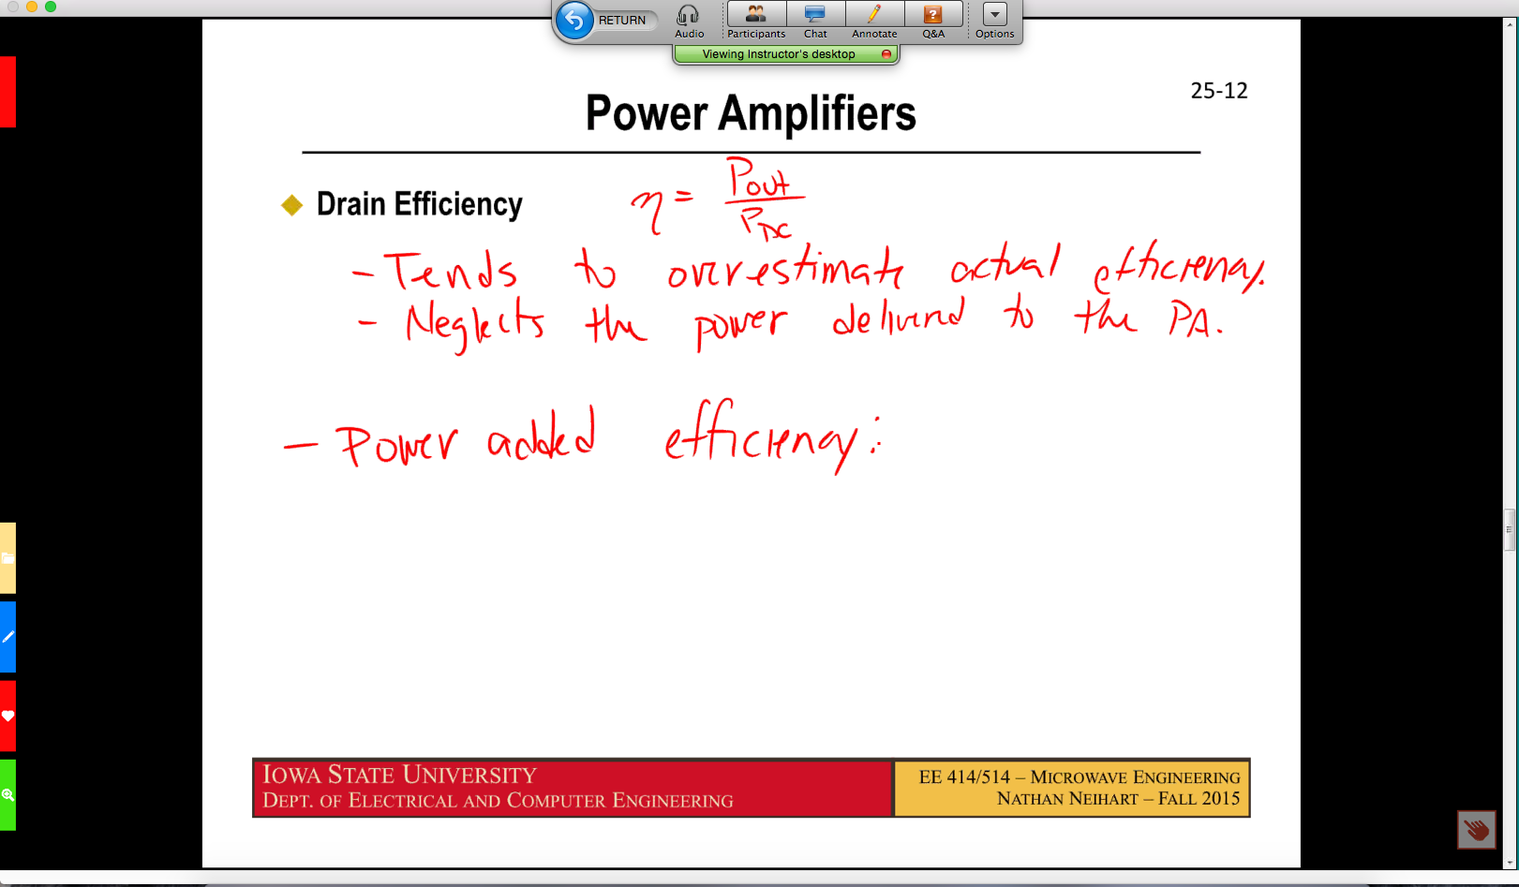

- Select Yes to hear audio for the class.

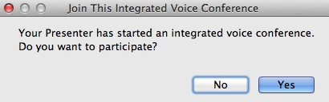

- You can set your speaker volume in the dialog box below.

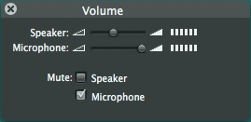

Note: You may want to do an audio test before start of your presentation.

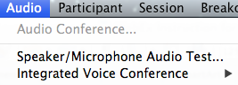

- If you are the presenter (made by the Instructor or ELO), you can select the webcam to share video of yourself with the audience.

- Click share my desktop to share content from your own screen with the audience.

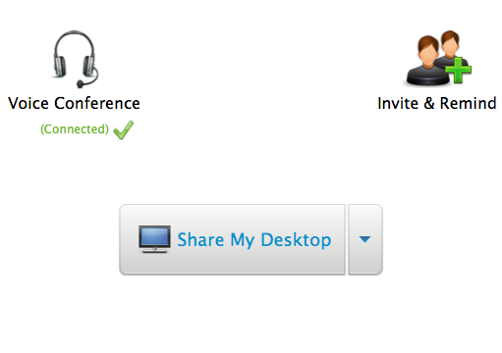

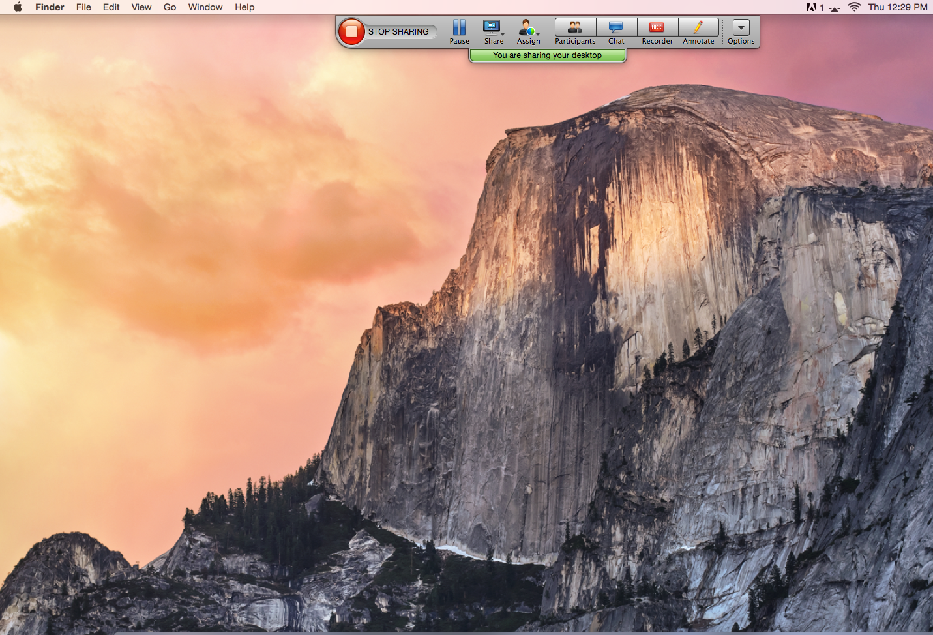

- Unmute the mic before speaking.

- Close the session at the end of class.

